**Facebook data set**

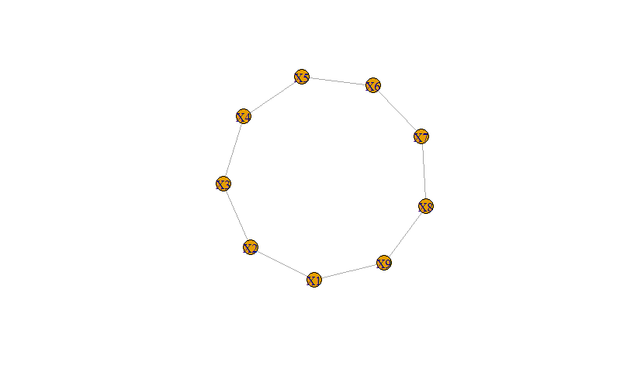

* Plotted the circular graph
* Assigned the data set into a adjacency matrix to plot the graph visually
* Then found out the 6 Node property values (indegree, outdegree, closeness, betweeness, eigen vector values, centrality, page rank, correlation)
* After finding all the values of node properties the values are coming out to be same .i.e in degree is equal to out degree .As facebook is a bidirectional the nno.of indegree can be equal to no.of out degree
* There won’t be any correlation as all values are same , They are neither increasing nor decreasing.

**Linkedin data set**

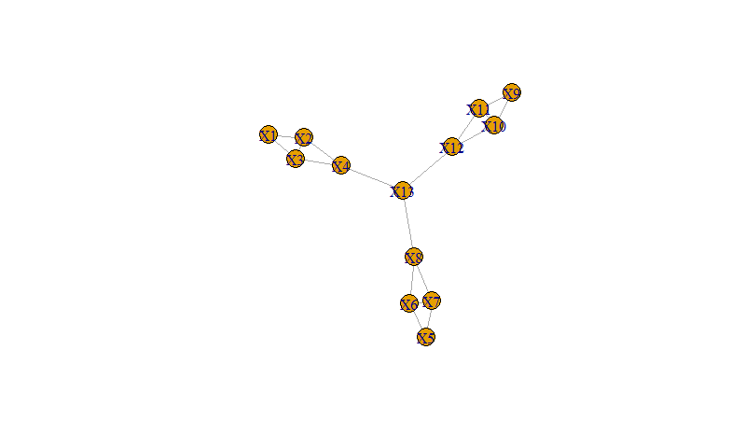

* Plotted the star graph
* Assigned the data set into a adjacency matrix to plot the graph visually
* Then found out the 6 Node property values (indegree, outdegree, closeness, betweeness, eigen vector values, centrality, page rank)
* In degree: The in degree values for all the nodes are 3 except for 1,5,9 nodes as they are only connected with 2 nodes directly and same implies for out degree so it is a undirected graph.
* Closeness: x13 is the node which is closest to the other nodes as it is having higher closeness value.
* Betweeness: x1,x5,x9 are having 0 betweeness and x4,x8,x12 are having same betweenness and the remaining pair is having same betweenness
* Eigen vector: The nodes x2,x3,x4,x6,x7,x8,x10,x11,x12 are having same eigen vector value indicating these nodes are the most important nodes to form this network
* Page vector: This is similar to the eigen vector. x2,x3,x4,x6,x7,x8,x10,x11,x12 are having same eigen vector value indicating these nodes are the most important nodes to form this network

**Instagram data set**

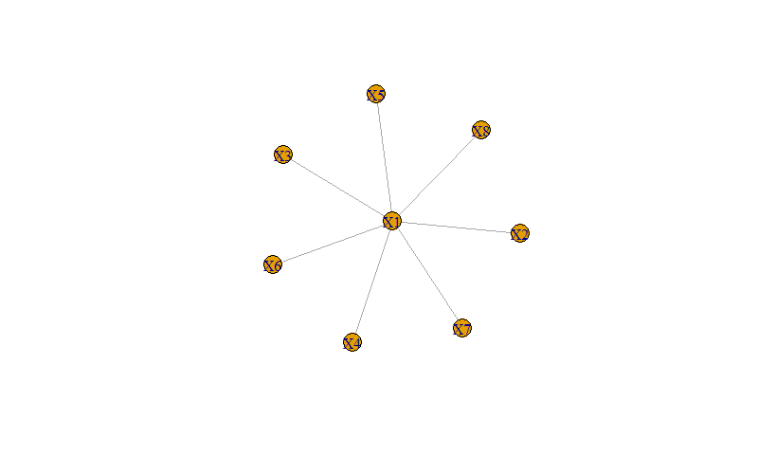

* Plotted the star graph
* Assigned the data set into a adjacency matrix to plot the graph visually
* Then found out the 6 Node property values (indegree, outdegree, closeness, betweeness, eigen vector values, centrality, page rank)
* In degree: The in degree values for all the nodes are 1 except for X1 node as that node is connected with 7 nodes directly and same implies for out degree so it is a undirected graph.
* Closeness: x1 is the node which is closest to the other nodes as it is having higher closeness value ,other nodes have equal closeness
* Betweeness: x1 is having ‘ 1’ betweeness and rest of the nodes are having same betweenness i.e 0
* Eigen vector: The node X1 is having highest eigen vector value indicating this node is the most important node to form this network
* Page vector: This is similar to the eigen vector. The node X1 is having highest eigen vector value indicating this node is the most important node to form this network

**Aeroplane data set inferences**

1. **Use the flights_hault and connecting routes datasets to find betweennes,closeness centrality, page rank, directed and undirected graphs.**

Inference : For both the directed and undirected graphs I got the same result after from the correlation between the in-degree and the out-degree which was 1 in case of undirected.The other results are as follows:

1)Max In-degree - Hartsfield Jackson Atlanta Intl(ATL)

2)Max out-degree - Hartsfield Jackson Atlanta Intl(ATL)

3)Max closeness centrality- Frankfurt Airport(FRA)

4)Max betweenness centrality – Los Angeles Airport(LAX)

5)Google page rank - Hartsfield Jackson Atlanta Intl(ATL)

6)Eigen vector centrality- Hartsfield Jackson Atlanta Intl(ATL)